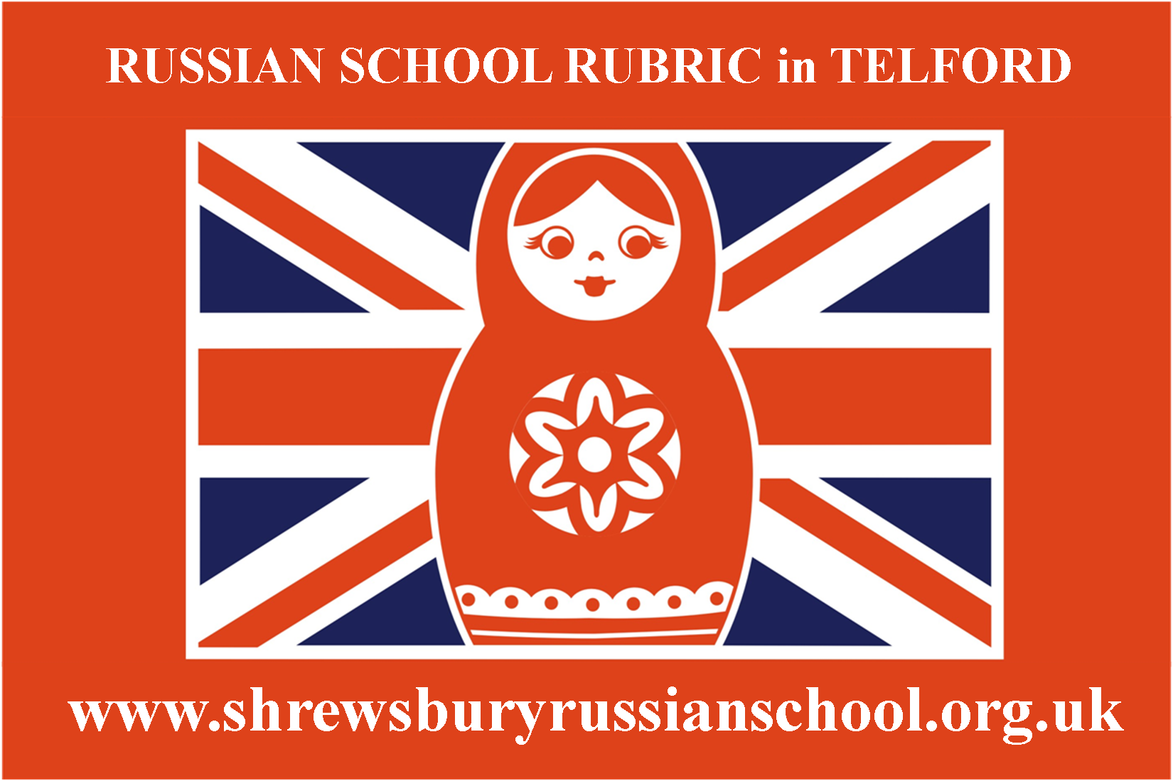
Telford Russian School RUBRIC

Application Form

- Please, let us know how many of your children plan to attend the Russian School? If more than one, please, fill in a separate questionnaire for each child (there is no need to repeat general answers)

- Tell us about your child: -
- Name
- Family name
- Gender
- Date of birth

- How would you estimate his/her current level of Russian language knowledge on a five-point scale:
- Understanding of language 1 2 3 4 5
- Informal conversation 1 2 3 4 5
- Reading 1 2 3 4 5
- Writing 1 2 3 4 5

- What language does your child normally speaks at home?

- Are there any other children in your family (besides the future pupil(s) of the school)? Please, indicate their age and level of knowledge of the Russian language.

- Does your child spend any time in a Russian-speaking environment (for example, in Russia), and if so, how often and for how long?

- What would you aim to achieve for your child by their attendance at the Russian school?

- To speak Russian
- To read Russian
- To write in Russian
- To pass examination GCSE in Russian
- Other (please, specify)
(Tick as appropriate)
8) Which subjects do you consider should be taught as either compulsory or supplementary in the Russian school? Please put appropriate mark against each subject:
! - compulsory,
+ - supplementary,
- - not required:
- Russian
- Russian literature
- Mathematics
- Russian history
- Regional geography (includes basics of geography, national culture, traditions, customs and Russian folklore, the former Soviet Union folklore)
- Art
- Music
- Fine arts
- Drama
- Dances
- General scientific subjects (physics, chemistry, biology etc.)
(Tick as appropriate)

9) Other subjects you may wish us co consider:

10) What main school does your child currently attends?

11) Are you interested in preparing your child for examinations for Secondary school - eleven plus (in English)?
- Yes
- No

12) Which kinds of activities is your child already engaged in?

13) What else is your child interested in/what does he/she like to do?

14) Are there any medical condition that we should be aware of?

16) In your opinion how does your child generally behave when he/she is in a group of other children? (For example - sociable, shy, quiet, leader, etc.)

17) Does your child like books:
- Very much
- Not so much
- Indifferent
(Tick as appropriate)

18) Which day of the week is more suitable for your child to attend the Russian school?
- Saturday
- Sunday
- Either
(Tick as appropriate)

19) What is your occupation?
- Yours
- Your spouse/spouse (partner)

20) Which area in Telford/Shropshire (surrounding) do you live in?

21) Your contact details:
- address:
- telephone:
- email:
- skype:
- Facebook account:

22) Where did you live before moving to England?

23) Your comments and opinion

